LSM Part 2 – Appendix 8.2.7.1

Peroxidizable and potentially explosive chemicals

Some laboratory chemicals, known as time-sensitive chemicals, can become dangerous with age and improper storage. This can be due to chemical reactions, over-pressurization of containers, increased toxicity, and other hazardous properties. There have been countless documented incidents handling these types of chemicals. For this reason, prudent handling and management of time-sensitive chemicals is critical. Laboratory personnel should be proactive with the management of time-sensitive chemicals and request KU-EHS pickup for any material that is expired or unwanted. The information in this document is intended to be used as a tool to assist laboratory workers in the safe management of these types of chemicals. Laboratory workers are encouraged to reach out to KU-EHS with questions about managing time-sensitive chemicals. Contact information is provided on page 8 of this document.

Peroxide Forming Chemicals
Some common laboratory chemicals, including organic solvents, can react with atmospheric oxygen to undergo autoxidation or peroxidation. These reactions produce unstable and dangerous organic peroxides and hydroperoxides. Formation of peroxides is accelerated by light and heat. Substances which have undergone peroxidation may be sensitive to thermal or mechanical shock and may explode violently. All laboratory workers should learn to recognize and safely handle peroxidizable compounds. A list of peroxide-forming chemicals is given in Appendix A. This list is not completely inclusive but rather a selection of commonly used chemicals that have demonstrated the ability to form peroxides. In Appendix B, a selection of common peroxide-forming functional groups is also provided.

Classification and Recommended Shelf Life of Peroxide-Forming Materials

Class A: Severe Peroxide Hazard on Storage
These are chemicals that form peroxides that may spontaneously decompose and become explosive regardless of concentration. These peroxides that are formed can be difficult to detect and eliminate. These chemicals are the most hazardous and can form explosive peroxide levels even when unopened. All have been responsible for fatalities. Test these items before use and dispose of these items within 3 months after opening or within 12 months if unopened.

Class B: Hazard Due to Peroxide Concentration
These chemicals require external energy for decomposition. These form explosive levels of peroxides when distilled, evaporated, or otherwise concentrated. For inhibited items, test for peroxides every 6 months and before concentration. Dispose of inhibited items within 12 months after opening or within 24 months if unopened. For, uninhibited items, test for peroxides before use. Dispose of uninhibited items within 3 months.

Class C: Auto-Polymerize as a Result of Peroxide Accumulation
These chemicals are highly reactive and can auto-polymerize because of internal peroxide accumulation. The peroxides formed in these reactions are extremely shock- and heat-sensitive. These may explode when relatively small quantities of peroxides are formed. These items normally have an inhibitor added to the substance by the manufacturer to prevent peroxides from forming. This inhibitor can be removed if it interferes with the use of the chemical or the chemical is redistilled in the lab. If a lab procedure requires the use of an uninhibited item in this Class, please contact KU-EHS for guidance. For inhibited items, test for peroxides every 3 months and before use. Dispose of inhibited items within 12 months. For uninhibited items, test before use. Dispose of uninhibited items within 24 hours of opening or within 3 months if unopened.

Class D: Miscellaneous
These chemicals have the potential to form peroxides with varying conditions of use but are normally stable. Consult the manufacturer’s SDS to determine when peroxide formation is expected and label accordingly. Test for peroxides every 6 months and before use. Dispose if peroxides are detected.

Table 1: Summary of Peroxide-Forming Chemical Classification

Classification | Hazard | Testing Frequency | Shelf Life Open | Shelf Life Unopened
Class A | Severe peroxide hazard | Before use | 3 months | 12 months
Class B, inhibited | Concentration | 6 months, before use | 12 months | 24 months
Class B, uninhibited | Concentration | Before use | 3 months | 3 months
Class C, inhibited | Auto-polymerization | 3 months, before use | 12 months | 12 months
Class C, uninhibited | Auto-polymerization | Before use | 24 hours | 3 months
Class D | Not clearly A, B, or C | 6 months, before use | When Test is + | When Test is +

Safe Storage and Handling
WARNING: The presence of crystals around the lid and/or inside the container, precipitates, or oily viscous layers are indicators of dangerously high levels of peroxides. For solid peroxide-forming chemicals, such as potassium metal or sodium amide, changes in color may be indicative of peroxide formation. Do not disturb, test, or treat any peroxide-forming chemical if any of the visible indicators are present or if you are unsure of the age. Contact KU-EHS immediately for guidance.
Peroxide-forming chemicals must have a KU-EHS Peroxide-Forming Chemical label filled out and attached to the bottle when received (Appendix D). It is recommended practice to only order and store chemicals in the smallest reasonable quantity and container size to minimize the associated risk. Solvents containing low levels of free radical scavengers such as BHT should be used whenever the presence of inhibitor does not interfere with intended application. Inhibitors can become exhausted with age and/or exposure to air, allowing peroxides to form. Uninhibited materials should be stored with care and frequently checked for peroxide formation.
Periodic testing for the presence of peroxides should occur based on the classification of the peroxide-forming chemical. All peroxide-forming solvents should be checked for the presence of any peroxides prior to distillation or evaporation. If peroxides are found at levels from 0-100 ppm and the chemical is useful material, the peroxides can be removed/quenched by various methods. If peroxides are found at a concentration above 100 ppm, contact KU-EHS immediately for Hazardous Waste disposal. The date and results of any testing must be placed on the container label.

Never use a metal spatula with peroxides. Contamination by metals or disturbance of any crystals can lead to explosive decompositions. Store peroxides and peroxide-forming chemicals according to the manufacturer’s recommendations, away from light, oxidizing agents, heat, and sources of ignition. Containers should be tightly closed, air-impermeable, and light-resistant. If storing peroxide-forming chemicals in a refrigerator, the refrigerator must be designed for the storage of flammable substances. Be sure to observe proper chemical segregation for chemicals inside of a refrigerator. Do not use domestic refrigerators to store flammable liquids.

Testing
These peroxide test methods are suitable to be used with most organic solvents. For substances such as alkali metals, alkali metal alkoxides, amides, and organometallics, there are no simple test procedures. Each test method has its own limitations and must be used as an approximation. Research the test method before use to ensure that it is compatible with the chemical needing tested. Record test results on the KU-EHS Peroxide-Forming Chemical label (Appendix D). A summary of test results is given in Table 2 along with guidance on what action should be taken.

Peroxide Test Strips:
Peroxide test strips are a convenient and commercially available way to test for peroxides. Test strips can detect some dialkyl peroxides, cyclic peroxides, and polyperoxides. Most test strips require you to dip the test strip into the solvent followed by dripping a drop of deionized water onto the reaction zone. Between the solvent dip and the water droplet addition, there is generally a waiting period for the solvent to evaporate from the test strip. KU-EHS uses EMD Millipore™ MQuant™ Peroxide Test Strips 110081 which have a detectable range from 0-100 ppm. Store the package of test strips in a fridge until it is opened. Once open, store the test strips at room temperature inside a desiccator to maximize the shelf life.

For solvents that are non-volatile, or only slightly volatile, the strip will not air dry. Allowing the excess solvent to drip off the strip and adding the water droplet will often allow the test to occur. An example of this is testing benzyl alcohol for peroxides.

Potassium Iodide Tests:
These tests are effective for the detection of hydroperoxides. There is some debate amongst researchers on whether these methods are sensitive to other types of peroxides. Some researchers recommend the use of different acids or even heating to detect other peroxides. Method I is generally faster than Method II (1 min vs. 15 min) for results.

- Add 1-3 mL of the liquid to be tested to an equal volume of acetic acid, add a few drops of 5% aqueous KI solution, and shake. The appearance of a yellow to brown color indicates the presence of peroxides. A blank determination should be made. Always prepare the iodide/acetic acid mixture at the time of testing because air oxidation slowly turns the blank to a brown color.

- Add 0.5 mL of the liquid to be tested to a mixture of 1 mL of 10% aqueous KI solution, and 0.5 mL of dilute HCl to which has been added a few drops of starch solution just prior to the test. The appearance of a blue or blue-black color within a minute indicates the presence of peroxides.

Ferrous Thiocyanate Test:
A drop of the solvent to be tested is mixed with a drop of sodium ferrothiocyanate reagent which is prepared by dissolving 9 g of FeSO₄-7H₂O in 50 ml of 18% hydrochloric acid. Add 0.5-1.0 g granulated zinc followed by 5 g sodium thiocyanate. When the transient red color fades, add 12 g more of sodium thiocyanate and decant the liquid from the unused zinc into a clean stoppered bottle. Pink or red coloration indicates the presence of peroxides. This test should only be used if hydroperoxides are expected. It is not useful for detecting most other peroxides.

Titanium Sulfate Test:
Dissolve a small amount of TiO₂ in hot concentrated sulfuric acid. Carefully add this to an equal amount of water to make a titanium sulfate solution in 50% sulfuric acid. This reagent will form a yellow-orange complex when added to a solvent containing peroxides. The sulfuric acid is claimed to hydrolyze the peroxides, which increases the reagent’s sensitivity to polyperoxides and other higher peroxides. There is a lack of research published on this test method and should only be used in comparison with another method of known sensitivity to the expected peroxides.

Table 2: Test Result Guidance

Test Strip Value | KI Test I Color | KI Test II Color | Fe(SCN)₂ Test Color | Action Needed
0-30 ppm | Slight yellow | Slight blue | Slight pink/red | Stabilize with an inhibitor. (hydroquinone, t-butyl catechol or ferrous sulfate) (between 1 and 250 ppm or about 0.1 mg inhibitor/L of solvent)
30-100 ppm | Bright yellow | Blue | Bright Red | May pose a hazard if stabilization is attempted. Tag the container and contact KU-EHS for a Hazardous Waste pickup.
>100 ppm | Dark yellow/brown | Dark blue/black | Dark Red | Do not attempt to stabilize. Tag the container and contact KU-EHS for a Hazardous Waste pickup

Stabilization
Source: "Disposal of Waste." National Research Council. 1995. Prudent Practices in the Laboratory: Handling and Disposal of Chemicals. Washington, DC: The National Academies Press. doi: 10.17226/4911.
(CAUTION: Peroxides are particularly dangerous. These procedures should be carried out only by knowledgeable laboratory workers.) Peroxides can be removed from a solvent by passing it through a column of basic activated alumina, by treating it with indicating Molecular Sieves®, or by reduction with ferrous sulfate. Although these procedures remove hydroperoxides, which are the principal hazardous contaminants of peroxide-forming solvents, they often do not remove higher peroxides, which may also be present in low concentrations. Commonly used peroxide reagents, such as acetyl peroxide, benzoyl peroxide, t-butyl hydroperoxide, and di-t-butyl peroxide, are less dangerous than the adventitious peroxides formed in solvents. After performing a stabilization procedure peroxide testing results are zero, add some inhibitor to as directed in Table 2 prevent further formation of peroxides.

Removal of peroxides with alumina:
A 2 x 33 cm column filled with 80 g of 80-mesh basic activated alumina is usually sufficient to remove all peroxides from 100 to 400 mL of solvent, whether water-soluble or water-insoluble. After passage through the column, the solvent should be tested for peroxide content. Peroxides formed by air oxidation are usually decomposed by the alumina, not merely absorbed on it. However, for safety it is best to slurry the wet alumina with a dilute acidic solution of ferrous sulfate before it is discarded.

Removal of peroxides with Molecular Sieves:
Reflux 100 mL of the solvent with 5 g of 4-8-mesh (or smaller) indicating activated 4A Molecular Sieves® for several hours under nitrogen. The sieves are separated from the solvent and require no further treatment because the peroxides are destroyed during their interaction with the sieves.

Removal of peroxides with ferrous sulfate:
ROOH + 2Fe²⁺ + 2H⁺ ROH + 2Fe³⁺ + H₂O
A solution of 6 g of FeSO₄ · 7H₂O, 0.6 mL of concentrated sulfuric acid, and 11 mL of water is stirred with 1 L of water-insoluble solvent until the solvent tests negative for peroxides. Usually only a few minutes are required.
Diacyl peroxides can be destroyed by this reagent as well as by aqueous sodium hydrogen sulfite, sodium hydroxide, or ammonia. However, diacyl peroxides with low solubility in water, such as benzoyl peroxide, react very slowly. A better reagent is a solution of sodium iodide or potassium iodide in glacial acetic acid.

Procedure for destruction of diacyl peroxides:
(RCO₂)₂ + 2NaI 2RCO₂Na + I₂
For 0.01 mol of diacyl peroxide, 0.022 mol (10% excess) of sodium or potassium iodide is dissolved in 70 mL of glacial acetic acid, and the peroxide added gradually with stirring at room temperature. The solution is rapidly darkened by the formation of iodine.

Most dialkyl peroxides (ROOR) do not react readily at room temperature with ferrous sulfate, iodide, ammonia, or the other reagents mentioned above. However, these peroxides can be destroyed by modifying the iodide procedure.

Procedure for destruction of dialkyl peroxides:
One milliliter of 37% (w/v) hydrochloric acid is added to the above acetic acid/potassium iodide solution as an accelerator, followed by 0.01 mol of the dialkyl peroxide. The solution is heated to 90 to 100 °C on a steam bath over the course of 30 minutes and held at that temperature for 5 hours.

Disposal

The following disposal methods are only for peroxide-forming chemicals that lack visible indicators of high levels of peroxides, such as those described in the Testing section. Any container that has visible indicators of peroxides should prompt immediate contact with KU-EHS.
Peroxide-forming chemicals shall be disposed by attaching a KU-EHS Hazardous Material label and contacting KU-EHS for Hazardous Waste pickup. If the peroxide concentration is greater than 100 ppm, please include that information in the pickup request.

Alumina used for the removal of peroxides shall be promptly slurried with the acidic ferrous sulfate solution described above under the Treatment section. This slurry shall be labeled with a KU-EHS Hazardous Material label listing alumina, sulfuric acid, ferrous sulfate, and whatever solvent the peroxides came from. Once labeled contact KU-EHS for Hazardous Waste pickup.

Shock-Sensitive and Potentially Explosive Chemicals

The following chemicals are known to be explosive or potentially explosive and need to be handled with care. The sensitivity and explosive potential of those compounds which are solids, is increased if they become dry. This list is not all inclusive. A selection of potentially explosive functional groups is provided in Appendix C. These types of chemicals should not be used without proper planning, training, and safety equipment.

Benzoyl peroxide; 94-36-0 | White crystalline solid; requires 25-35% water
2,4-Dinitrophenylhydrazine (DNPH); 119-26-6 | Red crystalline solid, requires >30% water
Methyl ethyl ketone peroxide (MEKP); 1338-23-4 | Colorless liquid; strong oxidizer
Nitrocellulose (NC); 9004-70-0 | White cotton-like solid highly flammable; Requires >25% water or alcohol
Nitroglycerin (NG)*; 55-63-0 | Colorless liquid
Nitromethane; 75-52-5 | Colorless liquid; highly flammable; Incompatible with Amines, oxidizers, strong acids, bases
Picramide (Trinitroaniline)*; 489-98-5 | Yellow crystalline solid; requires >30 % water
Picric acid (Trinitrophenol)*; 88-89-1 | Yellow crystalline solid; requires >30% water; Incompatible with metals, oxidizers, reducers
Picryl chloride (2,4,6-Trinitrochlorobenzene)*; 88-88-0 | White crystalline solid; requires >30% water; Incompatible with oxidizers, inorganic nitrates
2,4,6-Trinitrobenzenesulfonic acid (Picrylsulfonic acid)*; 2508-19-2 | Flammable solid, corrosive; requires >30% water
1H-Tetrazole; 288-94-8 | White/yellow crystalline solid
Trinitroanisole (Methyl picrate)*; 606-35-9
Trinitrobenzene*; 99-35-4 | Yellow crystalline solid; requires >30% water
Trinitrobenzoic acid*; 129-66-8
Trinitrotoluene (TNT)*; 118-96-7
Urea nitrate*; 124-47-0 | Colorless crystalline solid; requires >10% water
* Requires KU-EHS Safety Approval
Selected Time Sensitive Chemicals

Chloroform
Chloroform should be stored in a cool, dry, well-ventilated area and in tightly sealed containers. Chloroform decomposes at normal temperatures in sunlight in the absence of air, and in the dark in the presence of air. Phosgene is a decomposition product of chloroform. According to literature, the odor of phosgene is like musty hay. Phosgene exposure can cause damage to the central nervous system and can be fatal. Phosgene has a very low IDLH (Immediately Dangerous to Life or Health) concentration value of 2 ppm. Always open chloroform inside of a fume hood. When possible, chloroform that is stabilized with alcohol should be purchased. If non-stabilized chloroform is necessary for the work, it needs to be treated like a peroxide forming compounds and be used up or disposed of in a short amount of time. Amylene is often used as a stabilizer, however there is increasing evidence that it does not significantly prevent the formation of phosgene. Phosgene in the chloroform can be quenched by washing it with saturated carbonate solutions.

Formic Acid
Formic acid (90-100%) decomposes to form carbon monoxide and water. Pressure greater than 100 psi can develop with prolonged storage of one year or greater, which is sufficient to break a sealed glass container. Vent containers frequently and read the product literature. Some manufacturers add pressure relief lids to their containers as an additional preventative measure. Some Safety Data Sheets may recommend refrigeration.

Liquid Hydrogen Cyanide
Liquid hydrogen cyanide is a liquid that boils at 26 °C and is stored in low pressure cylinders. With no stabilizer (e.g. 1% sulfuric acid) present, polymerization can occur along with the production of ammonia which also helps catalyze the process. A crust can form on the liquid that, when jarred, can break off and fall into the liquid causing rapid exothermic polymerization and violently rupture of the cylinder. Liquid hydrogen cyanide use requires KU-EHS safety approval.

Alkali Metals
The Group 1 metals, as well as alloys of sodium-potassium, will react with dissolved oxygen when stored under mineral oil or kerosene. These reactions yield metal oxides as well as reactive peroxides and superoxides. Potassium and sodium-potassium alloys are of particular concern. A yellow crust or coating on potassium indicates the peroxide and/or superoxide is present. In a smaller percentage amount, potassium will also form the orange/red ozonide which is a highly sensitive explosive. Potassium superoxide and ozonide can explode or catch fire upon cutting. Cutting potassium should be avoided, especially after the expiration date. Rubidium and Cesium should only be stored in ampules and always handled under inert atmosphere. Lithium stored under nitrogen can form nitrides and argon should be used instead. The formation of lithium nitride is autocatalytic and can eventually autoignite/explode.

Corrosive Gases
Anhydrous compressed gases such as hydrogen fluoride, hydrogen bromide, hydrogen sulfide, hydrogen cyanide, and hydrogen chloride have a short shelf-life provided by the manufacturer which must be strictly adhered to. Gases such as hydrogen fluoride and hydrogen bromide may react with the steel walls of the cylinders to produce hydrogen. The gaseous hydrogen collects in the vapor space and builds pressure over an extended period. Hydrogen fluoride, hydrogen sulfide, and hydrogen cyanide use requires KU-EHS safety approval.

To minimize the possibility that the pressure would build to unsafe levels, cylinders should be pressure checked with a suitable pressure gauge during the manufacturer’s recommended maximum shelf life period (usually 2 years or less). Cylinders should be returned to the supplier after that time or if they are not being used. Some manufacturers do not accept lecture bottles for return, in this case contact KU-EHS for Hazardous Waste disposal.

Corrosive gases can also increase in risk over time. These gases can damage valves so they cannot be fully opened or closed. Valves on corrosive gases should be closed when not in use. Do not attempt to open a valve that is corroded as it may fail preventing closure. Ensure that gas cylinders are always clearly labeled. An unknown gas cylinder is a very expensive and dangerous situation.

A First In First Out (FIFO) inventory rotation should be applied to any cylinders that you may be using in your laboratory. The potential exists for pressure increases of several hundred psi to occur during the recommended storage time frame of Anhydrous HF. Pressures may continue to rise over longer storage periods. If you discover any HF cylinders that have been in storage longer than two years, immediately contact KU-EHS.

KU-EHS Contact Information
Department of Environment, Health and Safety: http://ehs.ku.edu/
Environment, Health and Safety (M-F, 8:00 am - 5:00 pm), 785-864-4089, ehsdept@ku.edu
EHS Hazardous Materials, (M-F, 8:00 am - 5:00 pm), 785-864-2853, hazmat@ku.edu

Additional Resources
- NRC (National Research Council), Prudent Practices in the Laboratory, Handling and Management of Chemical Hazards, National Academy Press: Washington, DC, 2011.
- NRC (National Research Council), Prudent Practices in the Laboratory, Handling and Management of Chemical Hazards, National Academy Press: Washington, DC, 1995.
- Clark, D., Peroxides and Peroxide-forming Compounds. J. of Chem. Health and Safety 2001, 8 (5), 12-22
- Kelly, R. J., Review of Safety Guidelines for Peroxidizable Organic Chemicals. Chemical Health and Safety 1996, 3, 28-36.
- Jackson, H. L.; McCormack, W. B.; Rondestvedt, C. S.; Smeltz, K. C.; Viele, I. E. J. Chem. Educ. 1970, 47, A175-A188.
- Burfield, D. R. J. Org. Chem. 1982, 47, 3821.
- Pitt, M. J. In Bretherick’s Handbook of Reactive Chemical Hazards 8th ed.; Urben, P. G. Ed.; Elsevier Ltd, 2017; pp 1336-1338.

Tables of Peroxide-Forming Compounds

Class A: Chemicals that are a severe peroxide hazard on storage.
Butadieneª; 106-99-0, 590-12-2 | Isopropyl ether; 108-20-3 | Sodium amide (sodamide); 7782-92-5
Chloropreneª; 126-99-8 | Potassium amide; 17242-52-3 | Tetrafluoroethyleneª; 116-14-3
Divinylacetylene; 821-08-9 | Potassium metal; 7440-09-7 | Vinylidene chloride; 75-35-4

Class B: Chemicals that form explosive levels of peroxides upon concentration.
Acetal; 105-57-7 | Dicyclopentadiene; 77-73-6 | Methyl isobutyl ketone; 108-10-1
Acetaldehyde; 75-07-0 | Diethyl ether; 60-29-7 | 4-Methyl-2-pentanol; 108-11-2
Benzyl alcohol; 100-51-6 | Diethylene glycol  dimethyl ether (diglyme); 111-96-6 | 2-Pentanol; 6032-29-7
2-Butanol; 78-92-2 | Dioxane; 123-91-1, 505-22-6, 5703-46-8 | 4-Penten-1-ol; 821-09-0
t-Butanol; 75-65-0 | Ethylene glycol dimethyl  ether (glyme); 110-71-4 | 1-Phenylethanol; 98-85-1, 1517-69-7, 1445-91-6
Cumene; 98-82-8 | Furan; 110-00-9 | 2-Phenylethanol; 60-12-8
Cyclohexanol; 108-93-0 | 4-Heptanol; 589-55-9 | 2-Propanol; 67-63-0
2-Cyclohexen-1-ol; 822-67-3 | 2-Hexanol; 626-93-7 | Tetrahydrofuran; 109-99-9
Cyclohexene; 110-83-8 | Methylacetylene; 74-99-7 | Tetrahydronaphthalene; 119-64-2
Decahydronaphthalene; 91-17-8 | 3-Methyl-1-butanol; 123-51-3 | Vinyl ethers
Diacetylene; 27987-87-7 | Methylcyclopentane; 96-37-7 | Other secondary alcohols

Class C: Chemicals that may auto-polymerize as a result of peroxide accumulation.
Acrylic acid^{b}; 79-10-7 | Methyl methacrylate^{b}; 80-62-6 | Vinylidene chloride; 75-35-4
Acrylonitrile^{b}; 107-13-1 | Styrene; 100-42-5 | Vinyl chloride; 75-01-4
Butadiene^{c}; 106-99-0, 590-12-2 | Tetrafluoroethylene^{c}; 116-14-3 | 2-Vinylpyridine; 100-69-6
Chloropreneª; 126-99-8 | Vinyl acetate; 108-05-4 | 4-Vinylpyridine; 100-43-6
Chlorotrifluoroethylene; 79-38-9 | Vinylacetylene; 689-97-4

Class D: Chemicals that may form peroxides but cannot clearly be placed in Tables A - C.
Acrolein; 107-02-8 | β-Chlorophenetole; 622-86-6 | Ethyl vinyl ether; 109-92-2
Allyl ether^{d}; 557-40-4 | o-Chlorophenetole; 614-72-2 | 2,5-Hexadiyn-1-ol; 28255-99-4
Allyl ethyl ether; 557-31-3 | m-Chlorophenetole; 2655-83-6 | 4,5-Hexadien-2-yn-1-ol; 2749-79-3
Allyl phenyl ether; 1746-13-0 | p-Chlorophenetole; 622-61-7 | n-Hexyl ether; 112-58-3
p-(n-Amyloxy)benzoyl chloride; 36823-84-4 | Cyclooctene^{d}; 931-88-4 | Iodophenetole (m-,o-,p-); 29052-00-4, 614-73-3, 699-08-1
n-Amyl ether; 693-65-2 | Cyclopropyl methyl ether; 540-47-6 | Isoamyl benzyl ether^{d}; 122-73-6
Benzyl n-butyl ether^{d}; 588-67-0 | 1,4-Dibutoxybenzene; 104-36-9 | Isoamyl ether^{d}; 544-01-4
Benzyl ether^{d}; 103-50-4 | 1,2-Dibenzyloxyethane^{d}; 622-22-0 | Isobutyl vinyl ether; 109-53-5
Benzyl ethyl ether^{d}; 539-30-0 | p-Dibenzyloxybenzene^{d}; 621-91-0 | Isophorone^{d}; 78-59-1
Benzyl methyl ether; 538-86-3 | 1,2-Dichloroethyl ethyl ether; 623-46-1 | β-Isopropoxypropionitrile^{d}; 110-47-4
Benzyl 1-napthyl ether^{d}; 607-58-9 | 2,4-Dichlorophenetole; 5392-86-9 | Isopropyl-2,4,5-trichlorophenoxy acetate; 93-78-7
1,2-Bis(2-chloroethoxy)ethane; 112-26-5 | Diethoxymethane^{d}; 462-95-3 | Limonene; 138-86-3, 5989-27-5, 5989-54-8
Bis(2 ethoxyethyl)ether; 112-36-7 | 2,2-Diethoxypropane; 126-84-1 | Phellandrene; 99-83-2, 555-10-2
Bis(2(methoxyethoxy)ethyl) ether; 143-24-8 | Diethyl ethoxymethylenemalonate; 87-13-8 | Methyl 4-pentoxybenzoate; 5416-97-7
Bis(2-chloroethyl) ether; 111-44-4 | Diethyl fumarate^{d}; 623-91-6 | 4-Methyl-2-pentanone; 108-10-1
Bis(2-ethoxyethyl) adipate; 109-44-4 | Diethyketene^{f}; 24264-08-2 | 2-Methyltetrahydrofuran; 96-47-9
Bis(2-ethoxyethyl) phthalate; 605-54-9 | Diethoxybenzene (m-,o-,p-); 2049-73-2, 2050-46-6, 122-95-2 | 3-Methoxy-1-butyl acetate; 4435-53-4
Bis(2-methoxyethyl) carbonate; 626-84-6 | 1,2-Diethoxyethane; 629-14-1 | Methoxy-1,3,5,7-cyclooctatetraene; 7176-89-8
Bis(2-methoxyethyl) ether; 111-96-6 | Dimethoxymethane^{d}; 109-87-5 | β-Methoxypropionitrile; 110-67-8
Bis(2-methoxyethyl) phthalate; 117-82-8 | Dimethylketene^{f}; 598-26-5 | m-Nitrophenetole; 621-52-3
Bis(2-methoxyethyl) adipate; 106-00-3 | 3,3-Dimethoxypropene; 6044-68-4 | 1-Octene; 111-66-0
Bis(2-n-butoxyethyl) phthalate; 117-83-9 | 2,4-Dinitrophenetole; 610-54-8 | Oxybis(2-ethyl acetate); 628-68-2
Bis(2-phenoxyethyl) ether; 622-87-7 | 1,3-Dioxepane^{d}; 505-65-7 | Oxybis(2-ethyl benzoate); 120-55-8
Bis(4-chlorobutyl) ether; 6334-96-9 | Di(1-propynyl)ether^{f}; 90993-57-0 | β,β-Oxydipropionitrile; 1656-48-0
Bis(chloromethyl) ether^{e}; 542-88-1 | Di(2-propynyl)ether; 6921-27-3 | 1-Pentene; 109-67-1
2-Bromomethyl methyl ether; 6482-24-2 | Di-n-propoxymethane^{d}; 505-84-0 | Phenoxyacetyl chloride; 701-99-5
β-Bromophenetole: 589-10-6 | 1,2-Epoxy-3-isopropoxypropane^{d}; 4016-14-2 | α-Phenoxypropionyl chloride; 122-35-0
o-Bromophenetole; 583-19-7 | 1,2-Epoxy-3-phenoxypropane; 122-60-1 | Propoxybenzene; 622-85-5
m-Bromophenetole; 2655-84-7 | p-Ethoxyacethophenone; 100-06-1 | p-Phenylphenetone; 613-40-1
p-Bromophenetole; 588-96-5 | 1-(2-Ethoxyethoxy)ethyl acetate; 112-15-2 | n-Propyl ether; 111-43-3
3-Bromopropyl phenyl ether; 588-63-6 | 1-Ethoxy-2-propyne; 628-33-1 | Triethylene glycol diacetate; 111-21-7
t-Butyl methyl ether; 1634-04-4 | 3-Ethoxyopropionitrile; 2141-62-0 | Triethylene glycol dipropionate; 141-34-4
n-Butyl phenyl ether; 1126-79-0 | 2-Ethylacrylaldehyde oxime; 99705-27-8 | 1,3,3-Trimethoxypropene^{d}; 17576-35-1
n-Butyl vinyl ether; 111-34-2 | 2-Ethylbutanol; 97-95-0 | 1,1,2,3-Tetrachloro-1,3-butadiene; 921-09-5
Chloroacetaldehyde diethyl acetal^{d}; 621-62-5 | Ethyl β-ethoxy-propionate; 763-69-9 | 4-Vinylcyclohexene; 100-40-3
1-(2-Chloroethoxy)-2-phenoxyethane; 2243-44-9 | Ethylene glycol monomethyl ether; 109-86-4 | Vinylene carbonate; 872-36-6
Chloromethyl methyl ether^{e}; 107-30-2 | 2-Ethylhexanal; 123-05-7

NOTES:
a When stored as a liquid monomer.
b Although these chemicals form peroxides, no explosions involving these monomers have been reported.
c When stored in liquid form, these chemicals form explosive levels of peroxides without concentration. They may also be stored as a gas in gas cylinders. When stored as a gas, these chemicals may auto-polymerize as a result of peroxide accumulation.
d These chemicals easily form peroxides and should probably be considered under Part B.
e OSHA - regulated carcinogen.
f Extremely reactive and unstable compound.

Peroxidizable Organic Moieties

Numbered from ‘Most’ to ‘Least’ likely to form dangerous peroxides

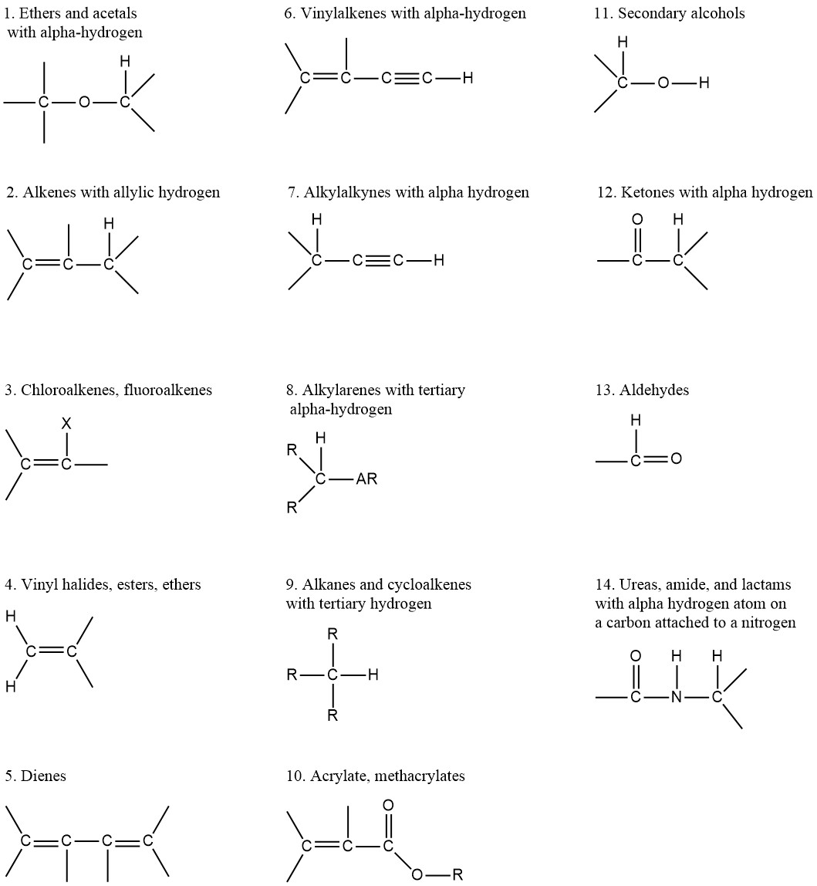

Functional Groups in Some Explosive Compounds
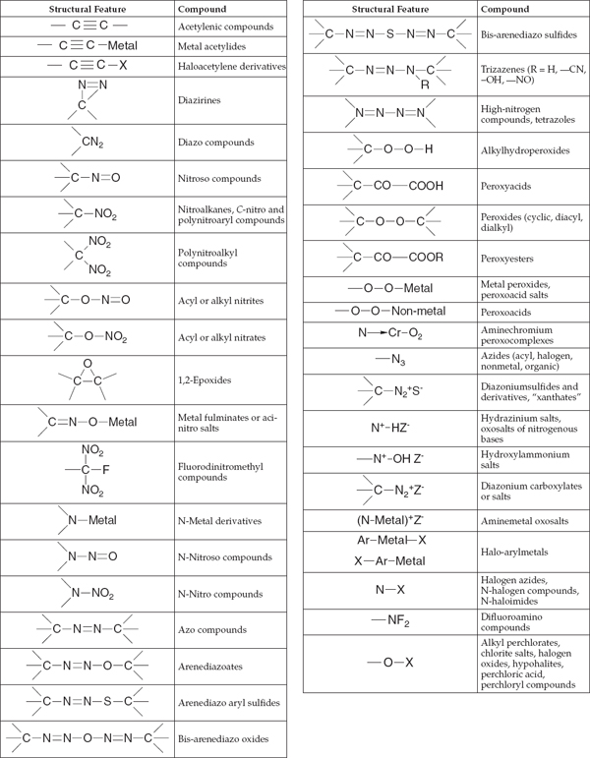
SOURCE: Carson and Mumford (2002). Reprinted from Hazardous Chemicals Handbook (Second Edition), Carson, P. and Mumford, C. “Reactive Chemicals”, p. 228, Copyright 2002, with permission from Elsevier.
Recommended Container Labeling

The following is an example of a completed KU-EHS Peroxide-Forming Chemical label. The label is printed duplex to have a two-sided label. This label is intended to be printed in color so that peroxide-forming chemicals are easy to recognize.

